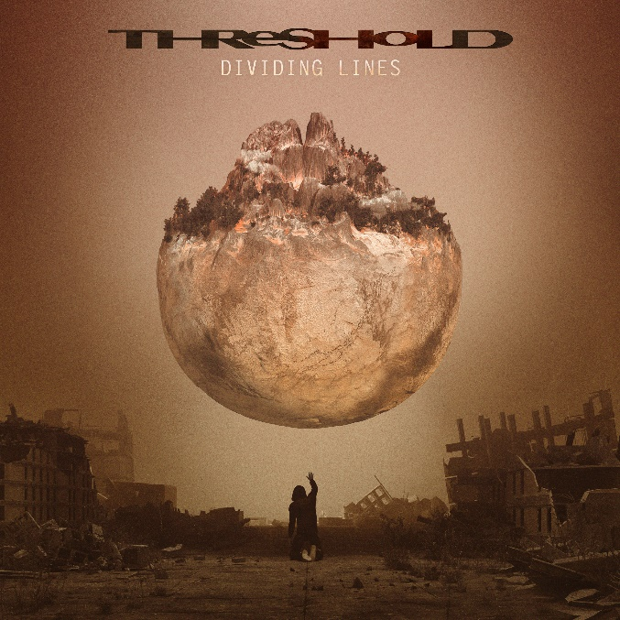

THRESHOLD

»Dividing Lines«

OUT: November 18th2022
Line up: | THRESHOLD online:
Glynn Morgan | vocals  Karl Groom | guitars  Richard West | keyboards  Steve Anderson | bass  Johanne James | drums | www.thresh.net  www.facebook.com/threshold  www.nuclearblast.de/threshold

Formed in leafy Surrey in the late ‘80s, THRESHOLD truly blossomed in the following decade, and swiftly established themselves as the UK’s chief progressive metal standard bearers. From 1993’s Wounded Land debut onwards, the enduring creative core of guitarist Karl Groom and keyboard maestro Richard West constructed a unique new strain of heavy, progressive music, combining incisive melodies, thought-provoking lyrics and intricate but thunderous arrangements. Whether fronted by current vocalist Glynn Morgan, who first sang with THRESHOLD on 1994’s Psychedelicatessen, the late, great Andrew ‘Mac’ McDermott (a member from 1998 to 2007), or three-time alumnus Damian Wilson, THRESHOLD have marched inexorably forward across three decades of creative fervour, arguably hitting a new peak of potency on the conceptual and musical splurge of 2017’s Legends Of The Shires. With Glynn Morgan back in the fold, the Brits’ enduring line-up of Groom, West, drummer Johanne James and bassist Steve Anderson somehow pushed themselves to new heights, receiving widespread acclaim and finding themselves in more demand than ever before. Despite the unavoidable setback of a global pandemic, THRESHOLD arrive in 2022 in the best of health.
“When we released Legends, it went down really well and it opened quite a few doors for us,” explains Richard West. “We ended up touring in a few places that we hadn’t been to before. Then we went out for another tour and played the album from top to bottom, which was great fun. We were just getting ready for more shows. We had an Australian tour booked, which was amazing after however many decades we’ve been going! It was the first time we’d had Australia on the books, so we were gutted that it was cancelled. But in 2020 we started writing a new album, in 2021 we recorded it, and we’re going to release it in 2022. So it’s been a long time coming!”
Following up a newly-minted classic was always going to present THRESHOLD with a challenge, but the band’s twelfth studio album swiftly confirms that the challenge has been met. Darker, heavier and even more adventurous than its predecessor, Dividing Lines reveals a band with a lot on their collective mind, while also boasting some of the most wildly inventive and melodically potent material they have ever recorded.
“We’ve described it as being Legends’ darker, moodier, older brother,” says West. “I think that some of that was intentional, but Legends was just its own thing, and Dividing Lines is its own thing too. When the songs came together there were more heavy moments and fewer lighter moments, so it built itself, in a way. With songs like Haunted and Silenced, I thought back to what it felt like when I was writing for albums like Subsurface, back in the 2000s, and just put myself back in that mind-space but with what I know now about production and music. I tried to revisit that, and I came up with something a bit different by doing that, which was fun.”
Despite its many tense and tumultuous moments, Dividing Lines is also a showcase for just how much fun THRESHOLD are having right now. Whether finding new ways to break hearts and touch souls on the streamlined, direct likes of Haunted, Silenced and Lost Along The Way, or exploring all kinds of new territory and re-tooled trademarks on elaborate epics The Domino Effect and Defence Condition, these ageless veterans are plainly in the form of their lives.
“I don’t know what it was, but when we wrote March Of Progress (2012) and To The Journey (2014), we somehow felt constrained by writing in a certain way,” says West. “With Legends, we just found more freedom. We decided to be a bit more progressive and to spread our wings more, and that made it great fun to write, and suddenly the shackles were off. On Dividing Lines, you get some weird twists and turns in songs like The Domino Effect that you wouldn’t necessarily have found on the earlier albums, just because we felt that freedom to go there. I feel like we’ve topped Legends, but it’ll be interesting to see what everyone else thinks!”
While Legends Of The Shires presented a self-contained narrative that enabled THRESHOLD to let their imaginations run wild, Dividing Lines eschews the conceptual approach in favour of a more traditional group of songs, linked by a hazy but unmistakable common theme.
“Legends carried more of a message of redemption, whereas Dividing Lines has got a tougher narrative – it’s more a collection of cautionary tales,” West explains. “It’s got a political commentary woven through it. It reminds me a little bit of our 2004 album Subsurface in that way, which had songs like Mission Profile, Art Of Reason and Opium, which looked at topics like propaganda, censorship and corruption. So it’s in that area. If there is a positive message to the album, it’s one about staying true to yourself, trusting your heart and not being swept away by what’s going on around you. But we’re living in uncertain times and the overall mood of the album reflects that.”
A collection of emotionally potent monuments to humanity’s eternal turmoil, Dividing Lines may be a dark record for dark times, but at its heart lies a message of hope for better times.
“The album title is about the walls between us, and how we always prefer to fight against each other instead of working together,” West notes. “It’s about how resentment builds up because we don’t know what to do when other people have a different point of view from us. It’s also about how we seem predisposed not to trust each other, and prefer to exist in a culture of ‘us and them’. However far we’ve come, we don’t seem to be able to stop drawing dividing lines.”
If the future of this planet looks bleak, at least the soundtrack will be spectacular. Dividing Lines is an album of shadows and light, of despair and hope; the human experience, rendered in dazzling, widescreen colours and performed with all the intensity and passion that has typified THRESHOLD’s more than three decades of active service. The UK’s kings of prog metal are back, and ready to conquer the world all over again.
“We’re waiting to see how things stand in the autumn. If it all looks okay, we’ll hopefully book up a tour for next spring,” West concludes. “With Legends, we played in about 20 countries, so I’m hoping we can do the same again, and hopefully get to Australia at last! We’re all really impatient! We just want to release the album. We want to get back out there. It’s been a long time, but it’s all going ahead so we’re really happy.”

